****GALGOTIAS UNIVERSITY

Plot No.2, Sector -17 A, Yamuna Expressway,

Greater Noida, Gautam Buddh Nagar, U.P., India

SCHOOL OF COMPUTING SCIENCE & ENGINEERING

Semi-conductor Physics

On

“Fermi-Dirac distribution and Fermi Level”

Course Name: Semi-conductor Physics

Course Code: BBS01T1002

School: SCSE

Program: B.Tech

Year: 1st Semester: 2

Session: 2021-2022

|  |  |
| --- | --- |
| Submitted By: | Submitted To: |
| Abhinav Kumar Choudhary  21SCSE1011615 | Mr. Sanjeev Kumar |

**The Fermi-Dirac Distribution Function and Fermi Level**

“Report”

This distribution describes the occupation probability for a state of energy E at a temperature T. This is the ground state of the *N* electron system at absolute zero. When the temperature is increased, The kinetic energy of the electron gas increases with temperature. Therefore, some energy levels become occupied which were vacant at zero temperature, and some levels become vacant which were occupied at absolute zero. The distribution of electrons among the levels isusually described by the **distribution function, f(E),** which is defined as the probability that the level *E* is occupied by an electron. Thus if the level is certainly empty, then*, f*(*E*) = 0, while if it is certainly full, then *f*(*E*) = 1. In general, *f*(*E*) has a value between zero and unity.

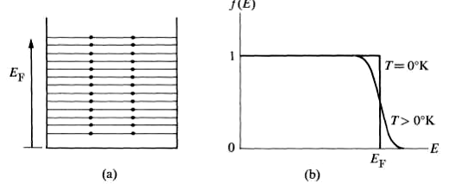

(a) Occupation of energy levels according to the Pauli exclusion principle,

(b) The distribution function *f*(*E*)*,* at *T* = 0°K and *T>* 0°K.

It follows from the preceding discussion that the distribution function for electrons at  *T =* 0°K has the form

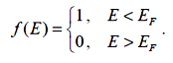

That is, all levels below *EF* are completely filled, and all those above *EF* are completely empty. This function is plotted in Fig. 1(b), which shows the discontinuity at the Fermi energy.

When the system is heated (*T>*0°K), thermal energy excites the electrons. However, all the electrons do not share this energy equally, as would be the case in the classical treatment, because the electrons lying well below the Fermi level *EF* cannot absorb energy. If they did so, they would move to a higher level, which would be already occupied, and hence the exclusion principle would be violated..

Therefore only those electrons close to the Fermi level can be excited, because the levels above *EF* are empty, and hence when those electrons move to a higher level there is no violation of the exclusion principle. Thus only these electrons - which are a small fraction of the total number - are capable of being thermally excited.

The distribution function at non-zero temperature is given by the *Fermi distribution function*.

The conduction band in a piece of semiconductor consists of many available, allowed, empty energy levels. When calculating how many electrons will fill these levels and thus be counted in n, contributing to conductivity, we consider two factors:

• How many energy levels are there within a given range of energy, in our case the conduction band, and

• How likely is it that each level will be populated by an electron.

The likelihood in the second item is given by a probability function called the Fermi-Dirac distribution function. *f(E)* is the probability that a level (orbital) with energy E will be filled by an electron at thermal equilibrium, and the expression is:

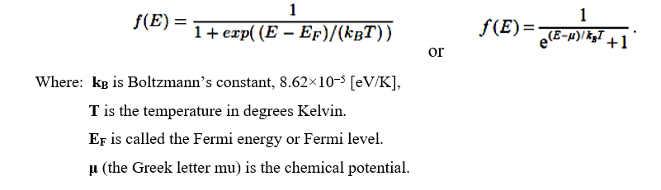

This function is also plotted in Fig. 1(b), which shows that it is substantially the same as the distribution at *T* = 0°K, except very close to the Fermi level, where some of the electrons are excited from below *EF* to above it.

The quantity **μ** is called the chemical potential. The chemical potential can be determined in a waythat the total number of electrons in the system is equal to *N*. At absolute   
zero **μ = *EF***.

In order to understand the behavior of electrons at finite temperature qualitatively in metals and pure undoped semiconductors, it is clearly sufficient to treat μ as a constant to a first approximation. With this approximation, the Fermi-Dirac distribution can be plotted at several different temperatures. In the figure below, μ was set at 5 eV.

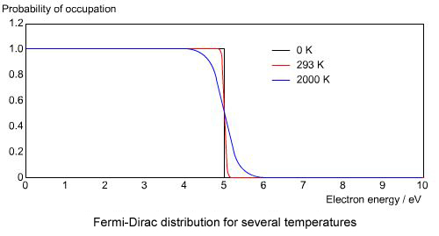

From this figure it is clear that at absolute zero the distribution is a step function. It has the value of 1 for energies below the Fermi energy, and a value of 0 for energies above. For finite temperatures the distribution gets smeared out, as some electrons begin to be thermally excited to energy levels above the chemical potential, μ. The figure shows that at room temperature the distribution function is still not very far from being a step function.

**THANK YOU**